3D modelling and print of robotic arm

**Robotic arm:-**

**A robotic arm is a type of mechanical arm. Which can perform near similar to human arm. Our robotic arm is specially designed by us for pick and place type task.**

**It is designed by online 3D design software**

**(tinkercad). And made using 3D printing technology.**

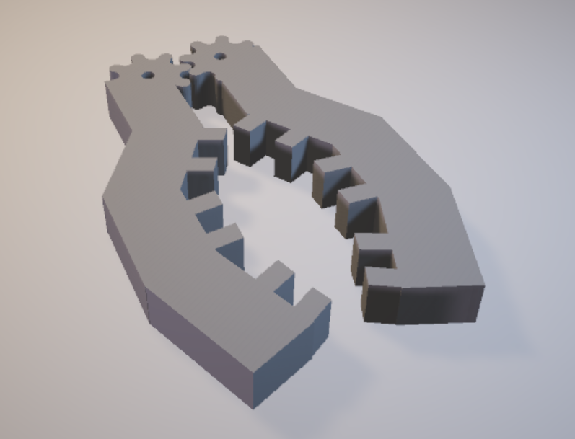

**Provided with multiple teeth structure for maximum grip. And angular structure for holding flat as well as round objects.**

**Design**

**We tried various shapes and sizes to obtain maximum grip as well as high strength. Previously we finalized ‘F’ shaped arms with 4 teeth on each arm. But it would fail to hold round shaped objects.**

**So we provided angles to arm & increased number of teeth so that it would hold the multiple sides of object and get maximum grip.**

**Gears are also added so that whole arrangement can be moved using single actuating element(servo motor).**

**This 3D structure is designed using an online software ‘tinkercad’.**

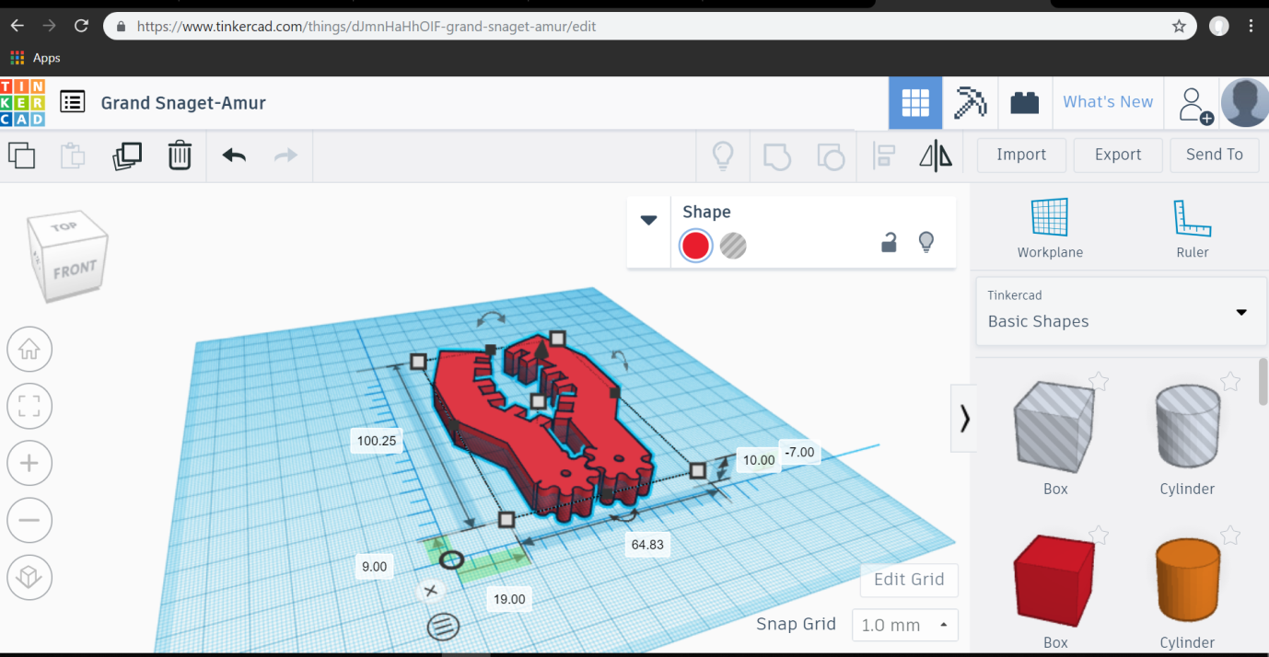

Printing

To fabricate this 3D object, we used 3D printing technology. A special machine called 3D printer can make this 3D structure. We have to provide only 3D object file(.stl file) & select the amount of material to be filled.

3D printer is an expensive machine that wasn’t available with us. So we took help of a company ‘Infinity Systems’ to fabricate that structure.

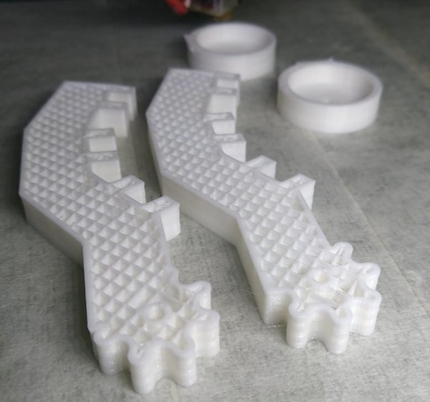

Material used:

Three type of materials can be used to print this object HIPS(high impact polysterene),ABS(Acrylonitrile Butadiene Styrene.) & PLA(polylactic acid).

Out of which [ABS](http://amzn.to/2mdb53v)  is [widely available](http://amzn.to/2mdb53v) and has been a very popular plastic in the development of prosumer 3D printing from the start. It melts consistently at around 225 degrees Celsius, which can easily be achieved with small and home-safe electronics.

[PLA](http://amzn.to/2lXFQJg) is made from corn starch or sugar cane and is biodegradable, so it’s more environmentally-friendly than ABS. It melts can melt at a lower temperature between 190 and 210 degrees and doesn’t smell bad when it does.

PLA also has high tensile strength(37Mpa)than ABS(27Mpa).

So by looking at these advantages we chosen PLA for our application. Because of high strength Only 25% fill of PLA can satisfy the application need.

Referances

3D Design <https://www.tinkercad.com/things/dJmnHaHhOIF-grand-snaget-amur/edit>

Materials <https://www.3dhubs.com/knowledge-base/pla-vs-abs-whats-difference>